Sprint 2 Plan

Plan-it

Team Rocket

11/3/2019

Revision 1, 10/23/2019

<https://app.clubhouse.io/teamrock/epic/37/plan-it?label_ids=83>

High level goal: *Allow users to add, save, and edit activities, and generate activity plans with these activities that fit their timeframe and budget.*

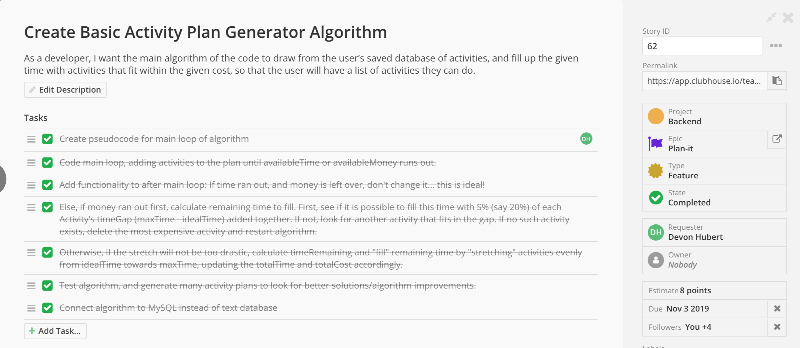

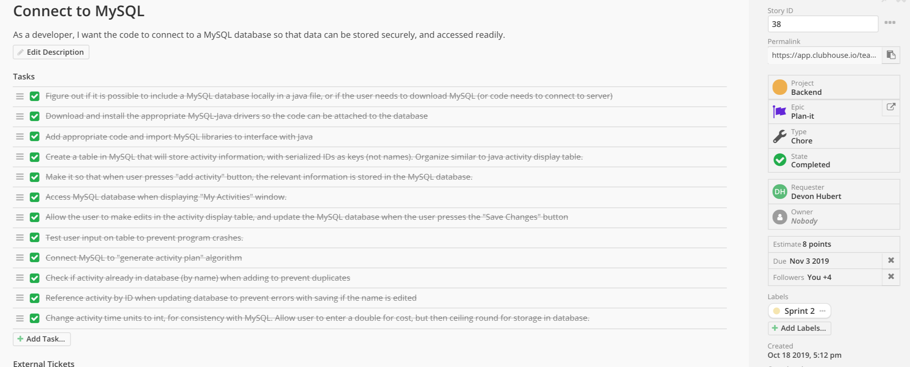

Meeting times: Monday, Wednesday, and Friday at 11:30. TA meeting on Wednesdays at 10:30 in room 316.